**Jacobs University Bremen**

**CO-526-B: Electronics Lab**

**Fall 2021**

**Lab Experiment 2: Diode**

**Priontu Chowdhury**

**Introduction**

The objective of this experiment is to become familiar with the semiconductor diodes and their application. A diode is a simple electronic device that allows passage of current in only one direction. However, it does not operate linearly to applied voltages, and therefore, is not governed by the Ohm’s law. It is a passive element, so it does not amplify power. Furthermore, it has two regions of operation: reverse biased region and forward biased region.

In forward bias condition, the current through a diode varies exponentially with the applied voltage. The relationship is approximated using the following equation:

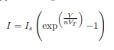

Is is the saturation current, and VT is the thermal voltage. These quantities are constant at a given temperature.

In reverse bias condition, the diode current is approximated by



**Zener Diode**

The Zener diode is a general purpose diode consisting of a silicon pn junction. When forward-biased, it acts like normal diodes, but in reverse bias if the reverse voltage is increased the saturation current remains essentially constant until the breakdown voltage is reached where the current increases dramatically. The breakdown voltage is called the Zener voltage for Zener diodes.

**Diode Application**

A diode rectifies and AC voltage, so that it can be smoothed and converted to a DC voltage. The following networks are two types of rectifiers:

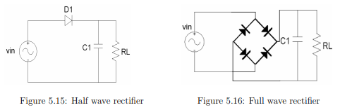

In case of half wave rectifier, we can calculate peak-to-peak ripple using the following formula:

**Prelab: Diodes**

**Problem 1: Current/Voltage characteristic of a Diode**

For this part, we implement the following circuit in LTSpice:

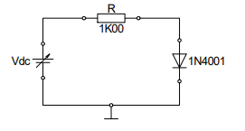

The circuit looks as follows:

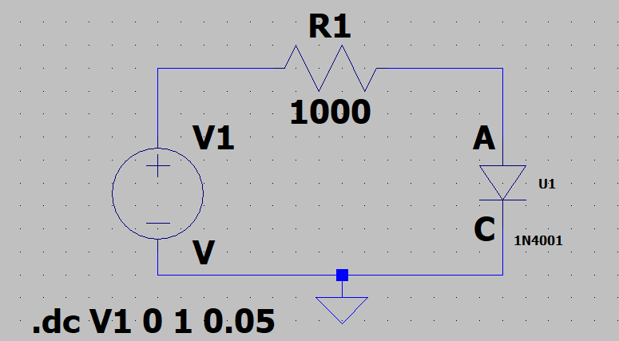

Then, we are ready to perform a DC Sweep analysis.

First, we plot the forward diode current I versus the diode voltage V using a linear scale. The outcome is the following:

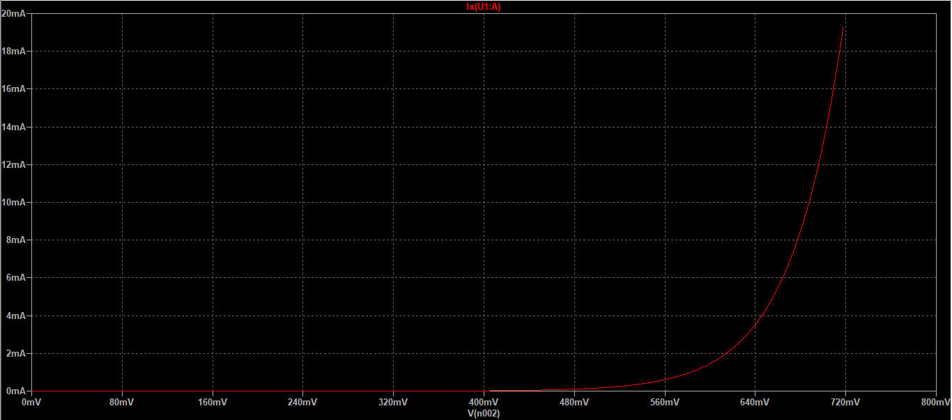

Now that we have the plot, we obtain the following in semi-log plot (log(I) versus V):

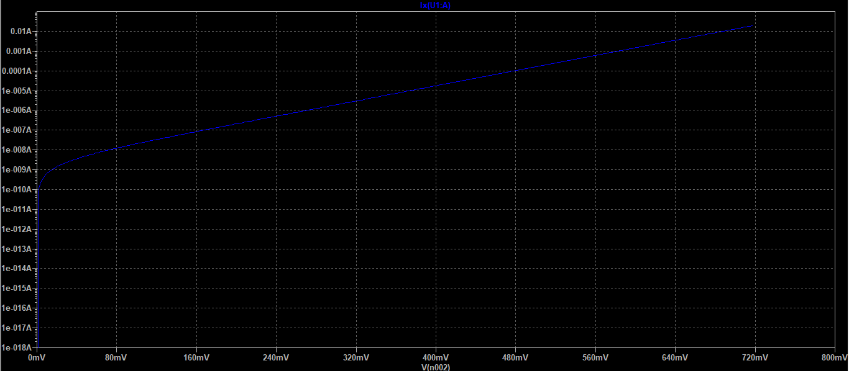

From these results, we can determine ideality factor ‘n’ and saturation current ‘Is’.

We know,

We make the following substitutions:

From the plot above, we obtain the following points:

Using these points, we are able to construct the following linear system of equations:

We add the equations to eliminate y and then solve for x. Once we have x, we can input its value in equation 2 to determine y.

We obtain the following results:

**Problem 2: Halfwave rectifier**

For this task, we implement the following circuit using LTSpice:

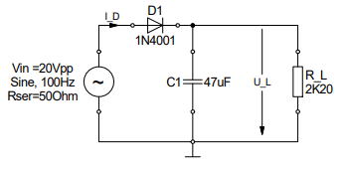

We then perform transient analysis with 4 cycles of sinusoidal input using the following parameters:

.tran 0 1 960m 0.05m

The circuit looked as follows on LTSpice:

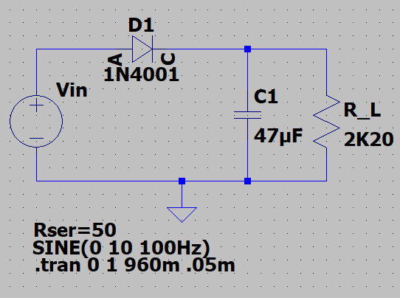

Task 1

After we have the circuit, we simulate the circuit without C1 and plot U_L, Vin and ID.

The simulation is provided below:

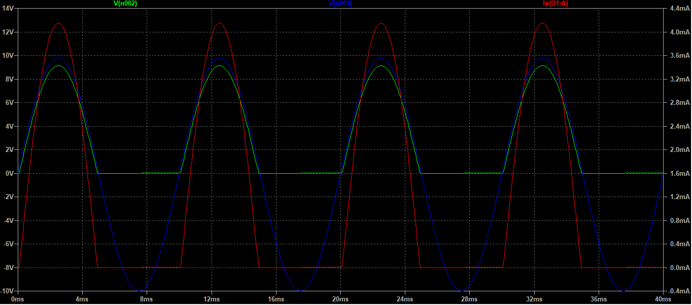

Task 2

From the simulation, we measure the peak voltage at R_L and I_D using the cursors. We found the following results:

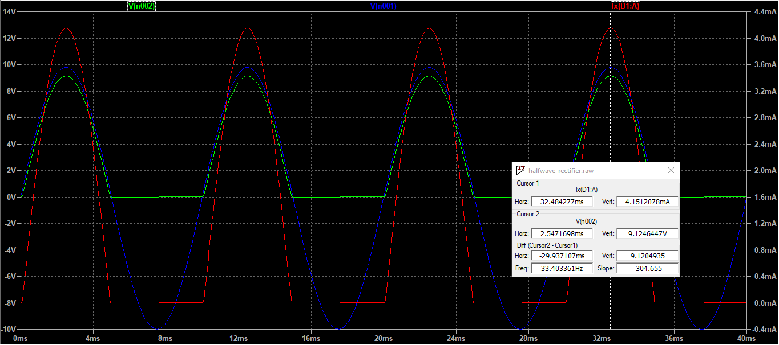

The results we obtained are as follows:

Peak votlage across R_L = 9.125V

Peak current I_D = 4.151mA

Task 3

Now, we simulate the circuit with capacitor C1 connected, and plot U_L, Vin and I_D. The plot is provided below:

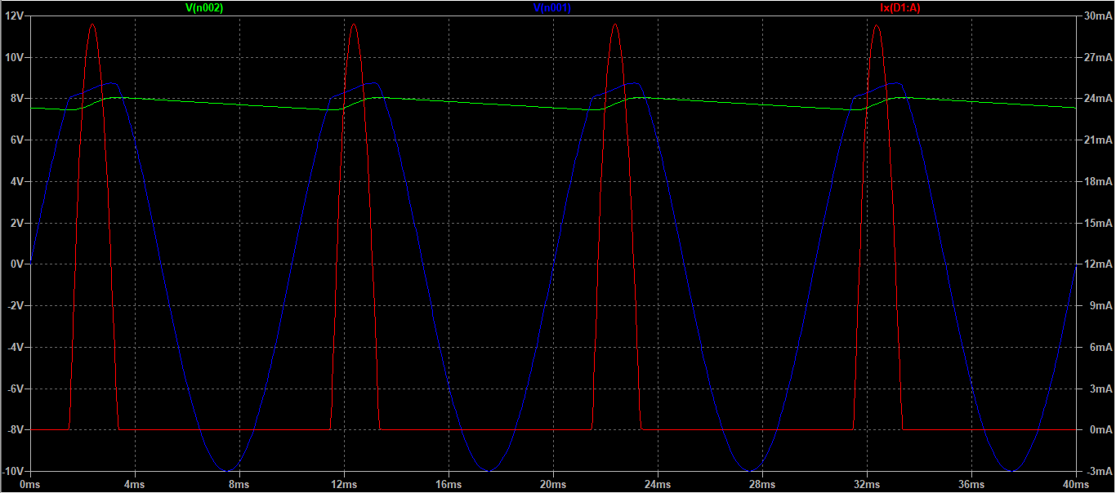

Task 4

We again used the cursors to measure the peak voltage and current:

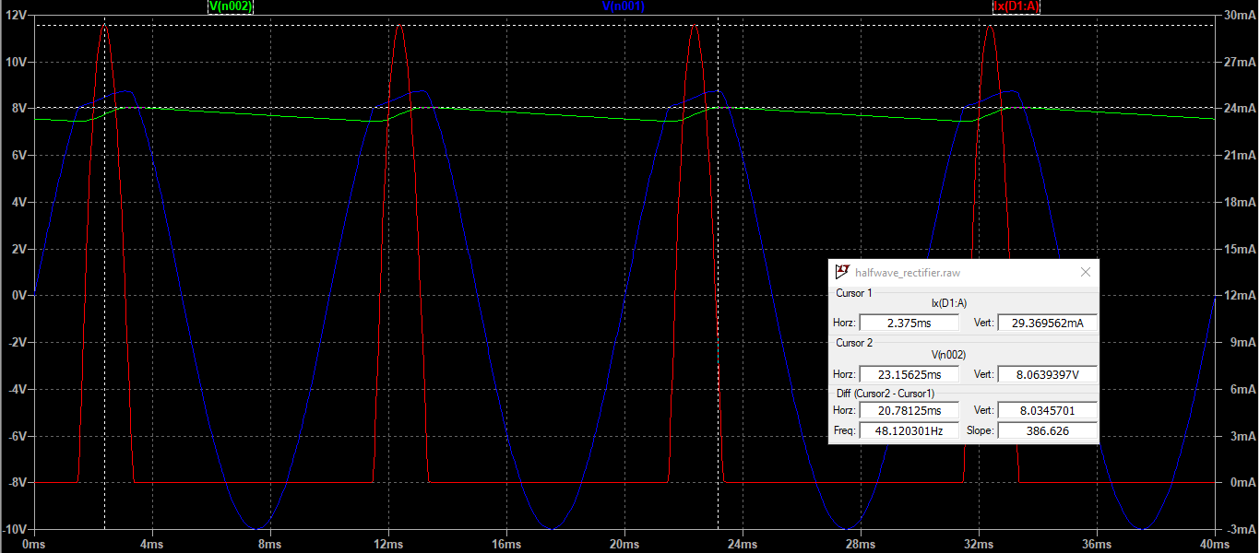

Peak voltage at R_L = 8.064V

Peak current I_D = 29.37 mA

Task 5

Using the cursors to determine the ripple voltage, we find the following value from the simulation:

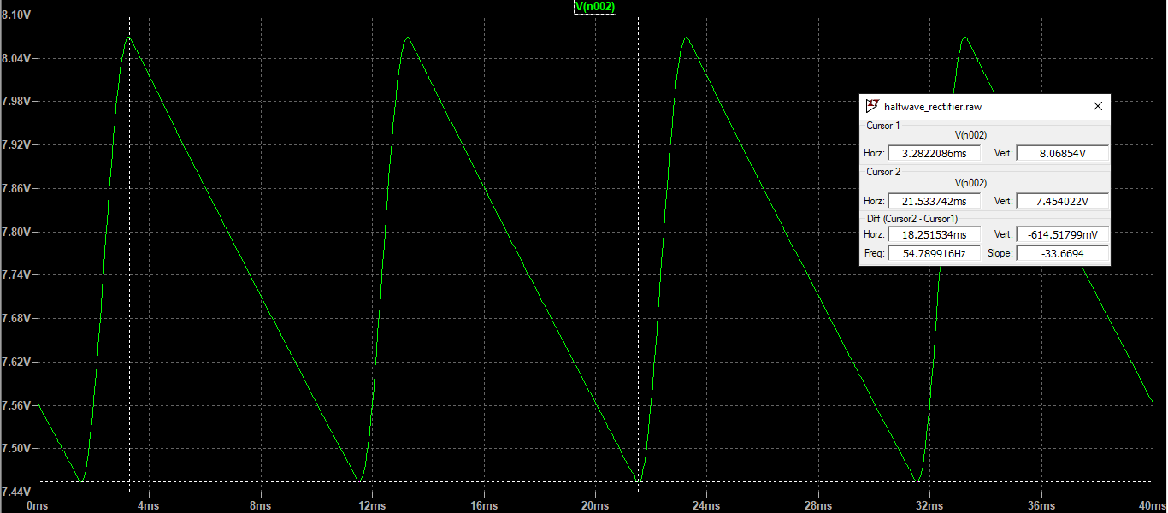

We can obtain a theoretical value for the ripple by using the following:

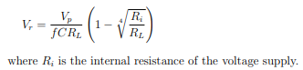

Our simulated Vr differ from the theoretical value by about 20.98mV. The values are relatively close. The simulated value has an error of approximately 4%. It is possible that this occurred due to limited resolution of the simulation, or precision error when taking measurements using cursor.

**Problem 3: Full wave rectifier**

For this section, we are required to implement the following circuit:

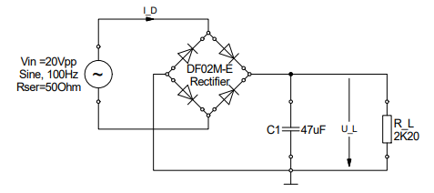

On LTSpice, the circuit looks as follows:

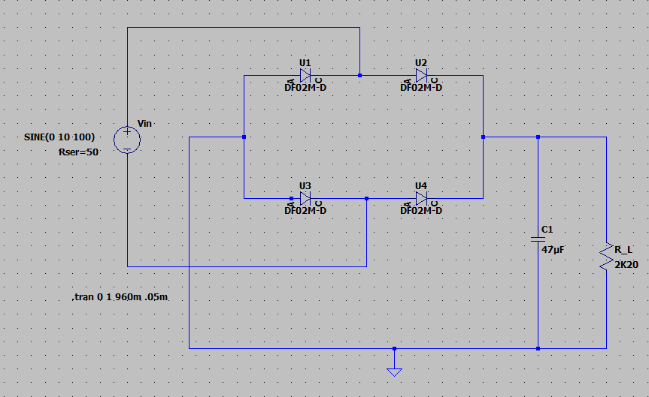

Task 1

Without C1, the simulation looks as follows:

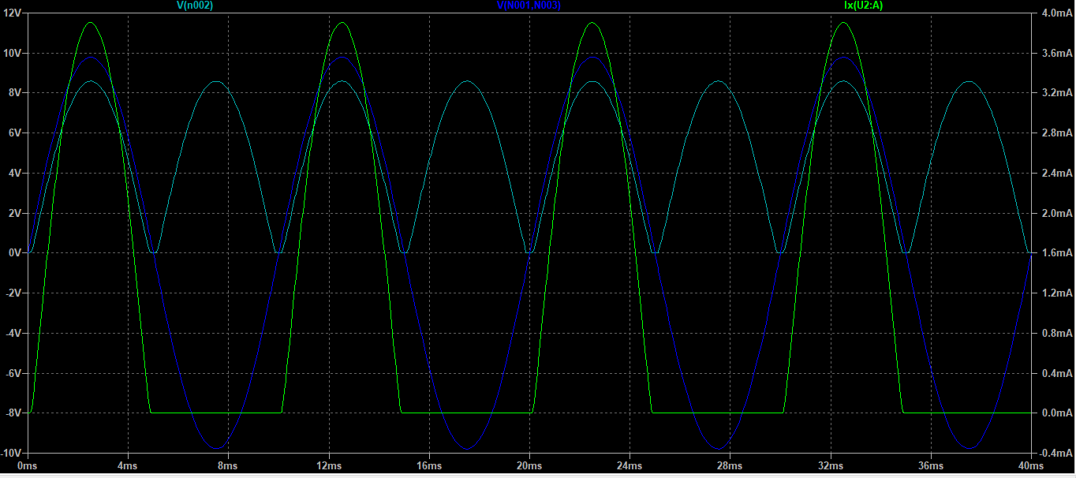

Task 2

Using the cursors, we obtain the following measurements for peak voltage at R_L and peak current I_D:

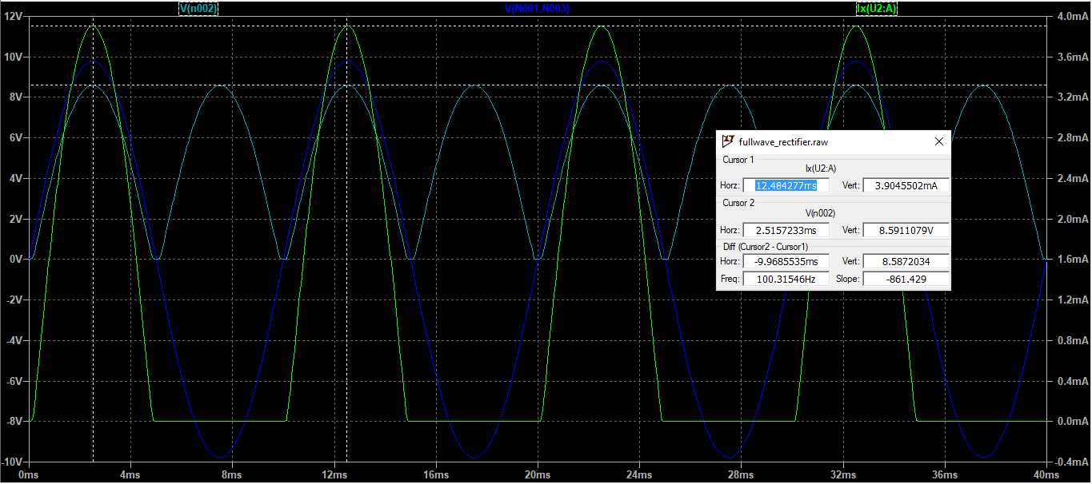

𝑃𝑒𝑎𝑘 𝑣𝑜𝑙𝑡𝑎𝑔𝑒 𝑎𝑡 𝑅_𝐿 = 8.5911079𝑉

Task 3

With C1 connected, the simulation looks as follows:

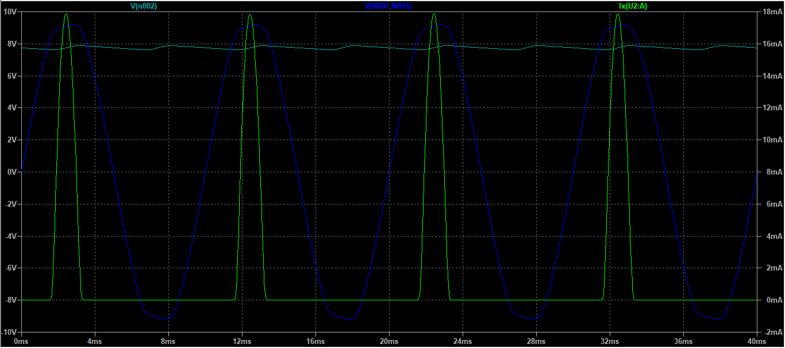

Task 4

Peak voltage and peak current are provided as follows:

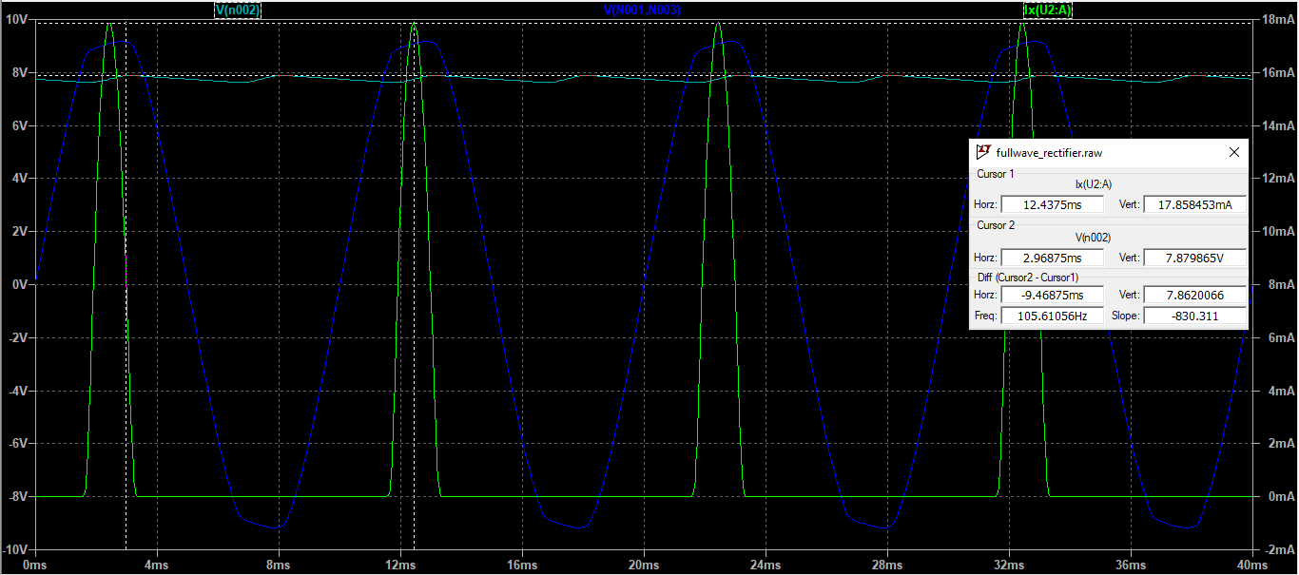

Task 5

The ripple of the voltage at the load resistor can be measured as follows:

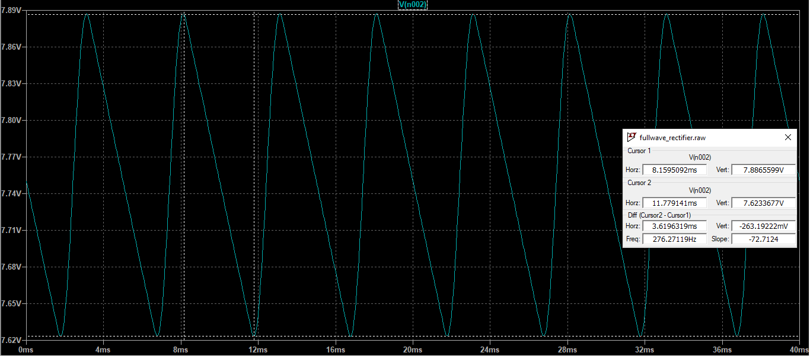

To calculate the theoretical ripple voltage, we use the following formula:

The values have a difference of 32.61mV. In this case also, the error is small, and the values are very close to each other. The error could arise due to resolution of the plot or the precision error when taking measurements using the cursor.

**Problem 4: Rectifier**

A rectifier is a device that is used to convert a two-directional AC signal to a single-dimensional DC signal. For example, when a two-directional oscillating AC sine wave is passed through a rectifier, the output is a single-directional signal, as shown below:



In the diagram above, V(n002) is the output directly out of the rectifier and V(N001, N003) is the input. As we see, the input signal changes direction, but the output signal doesn’t.

Although the output flows in a single direction now, it’s not useful because of the large leaps in the single directional output. The time-based variation in the output is too large. This issue is countered by using a capacitor, which acts as a smoothing filter. It smoothens the output curve by charging when the voltage across load is higher than the voltage of the capacitor and discharging when the voltage across the load is lower than that of the capacitor. Ideally, the DC signal would become a flat line, which signifies a constant DC voltage. However, In our simulation, the filtering process is not perfect, so we are left with a ripple at the output.



Task 1

Maximum peaks for each rectifier:

Half wave rectifier:

Without capacitor: Peak votlage across R_L = 9.125V

With capacitor: Peak voltage at R_L = 8.064V

Full wave rectifier:

Without capacitor: Peak voltage at R_L = 8.5911079V

With capacitor: Peak voltage at R_L= 7.879865V

There are voltage drops across the diodes and the internal resistance of the signal generator, so the load does not receive the full input signal. As a result, the values are different from the input sine amplitude.

In case of the half wave rectifier, we use only one diode, so the negative half-cycles of the input are cancelled completely. As a result, the capacitor discharges during the span of those half cycles. This results in a large ripple.

In the case of a full-wave rectifier, we a diode network which inverts the negative input cycles, which means at the output a positive cycle starts immediately at the end of the previous one. As a result, the capacitor discharges for a much shorter time span, and is fully charged more frequently. Therefore, the output is smoother, and the ripple is smaller.

Task 2

The current through the diode depends on presence of capacitor and the type of rectifier device being used. Presence of a rectifier results in current amplitudes that are larger.

In presence of a capacitor, current flows through the load and diode when the diode is forward biased. There is no current flow otherwise.

With capacitor, current flows through the load at all times. When the diode is forward biased, there is a current flow as a result of the source, and the capacitor charges. When the diode is reverse biased, the capacitor discharges onto the load, which results in a current flow.

Furthermore, the amplitude of current in half-wave rectifier circuit is higher than that of the full-wave rectifier circuit.

An additional consequence of the presence of the diode is that the input voltage is divided between the resistor and the diodes in series with it, so the overall output voltage is lower than the input.

Task 3

The larger the ratio C*R_L, the smoother the DC output or the smaller the ripple. As a result, we have a better filter.

**Problem 5: Zener Diode**

For this section, we are required to implement the following circuit:

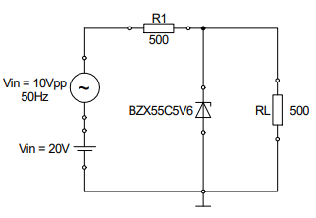

The circuit looks as follows on LTSpice:

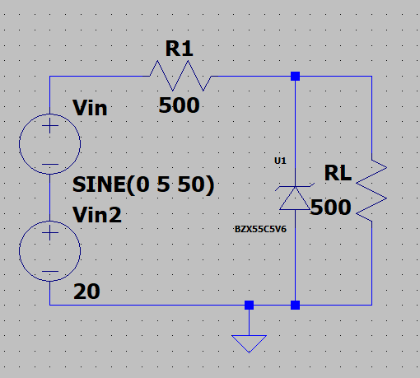

Task 1

Now that we have the circuit, we perform a transient analysis with 5 cycles of sinusoidal input. The input and output is plotted below:

The output voltage across load:

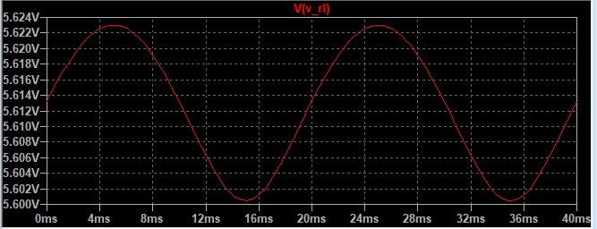

Output current across load:

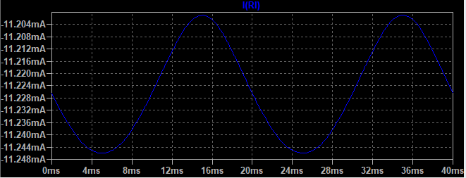

Input voltage and current (AC+DC):

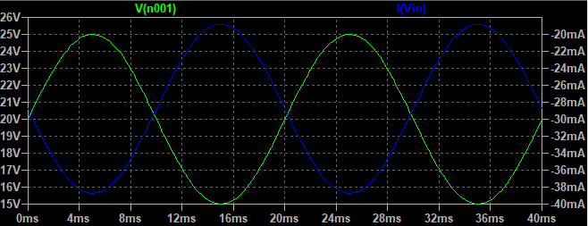

Overall:

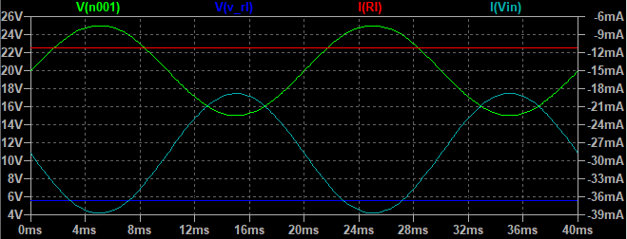

Task 2

This is a voltage regulator circuit, which is designed in such a way so that the voltage and current across the load is always constant, independent of fluctuations of the input voltage and current. From the simulation, we see that although the input voltage of the load varies significantly () over time, the voltage across the resistor remains relatively constant (). The Zener diode consumes the more current or less current depending on the situation to make this possible.

**Experimental Set-up and Results**

**Problem 1: Diode Switching Characteristic**

The goal of this task is to investigate the reverse/forward and forward/reverse transition behavior of a rectifier and a signal diode. In order to accomplish this, we first assemble the following circuit on the breadboard:

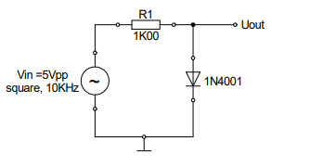

We find that there exists a delay time during the reverse/forward transition and a storage time after the forward/reverse transition. In the lab manual, this is demonstrated as follows:

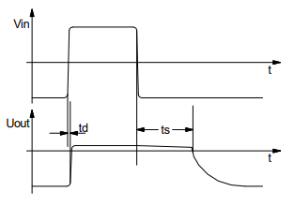

The results of the oscilloscope are the following:

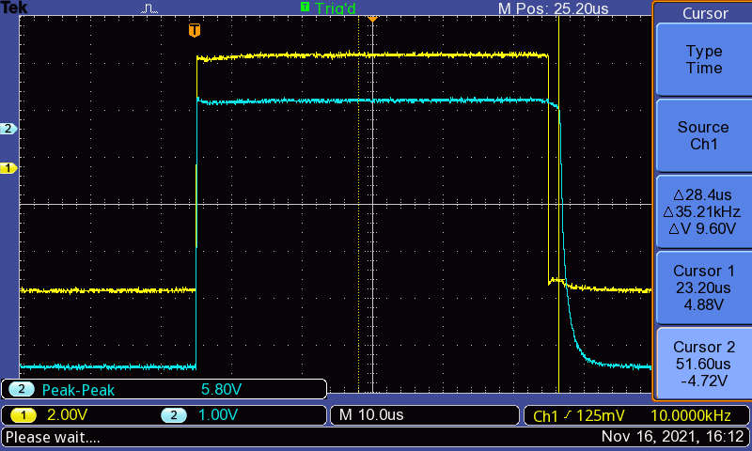

We are required to measure td and ts, as demonstrated in the manual.

We obtain the following measurements:

Falling Edge:

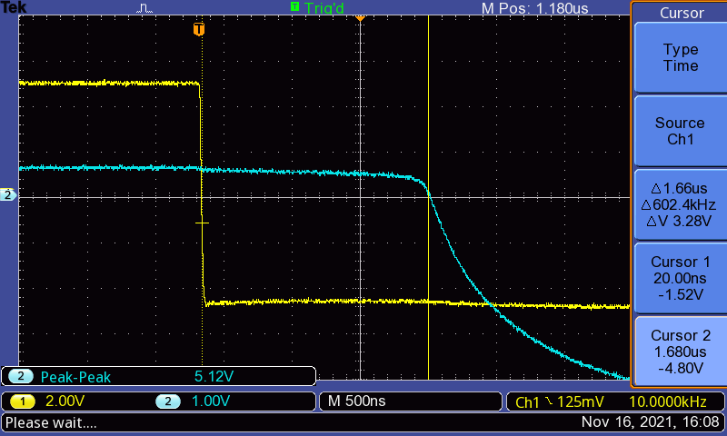

Rising edge:

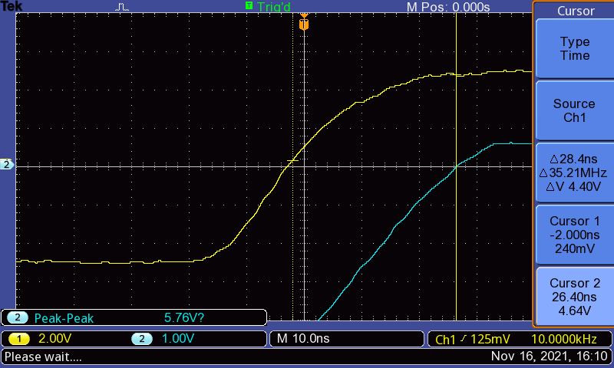

We then replaced the 1N4001 rectifier diode with the 1N4148 signal diode, and repeated the ts measurement. We found the following results (falling edge):

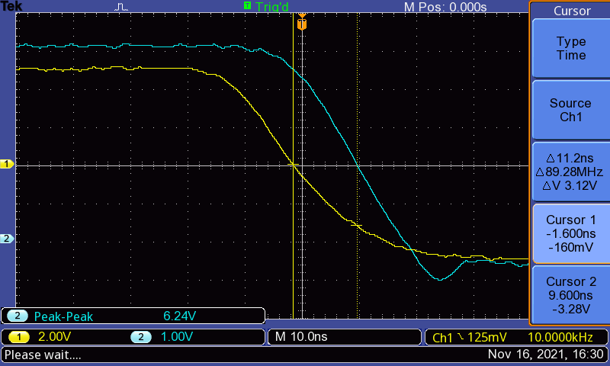

**Problem 2: Rectifier**

Task 1: Half wave rectifier

For this task, we implemented the following circuit on the breadboard:

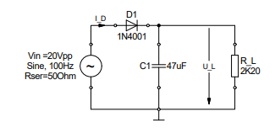

Then, we took a hard copy of the output voltage across R_L with C1 removed from the circuit.

A measurement of the peak voltage is included:

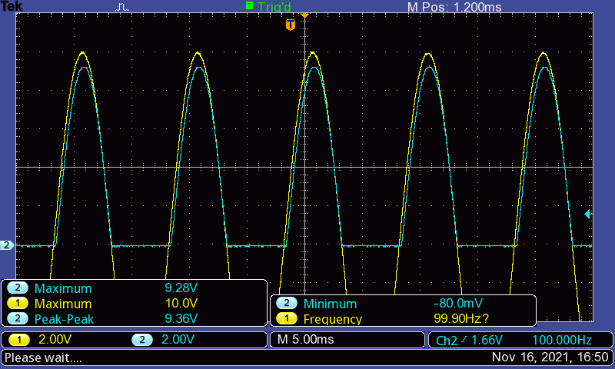

Then we connected C1 and reexamined the output, provided as follows:

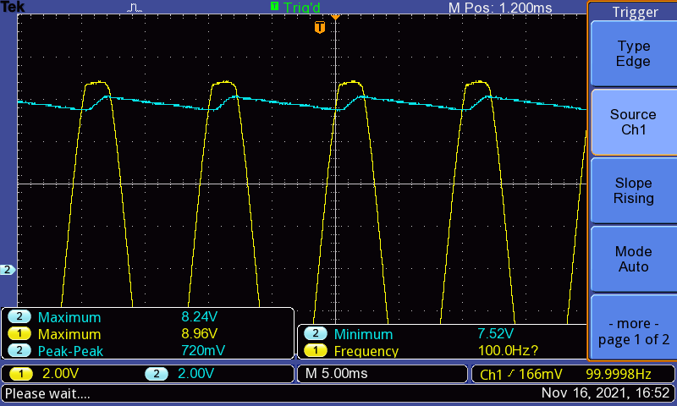

Next, we expanded the ripple voltage. We acquired a hardcopy of the output with measurement of peak-to-peak voltage included:

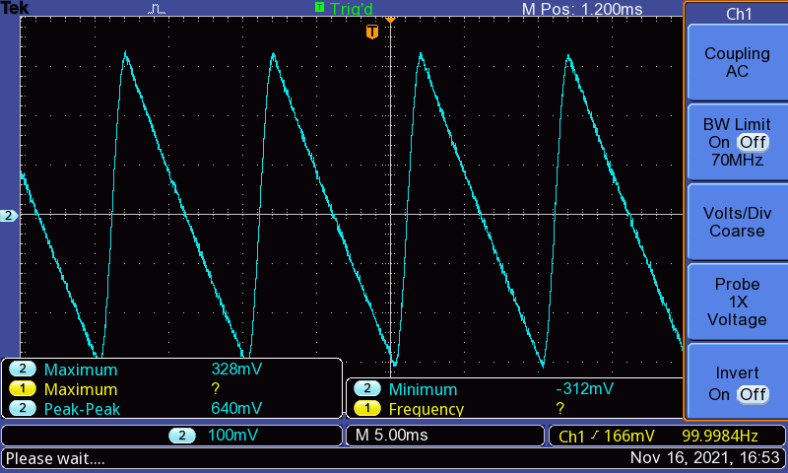

Task 2: Full-wave rectifier

For this task, we implemented the following circuit:

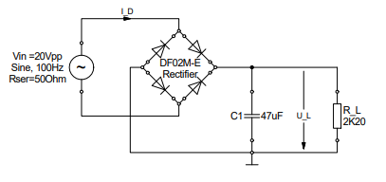

We first removed C1 and took a hard copy of the output with measurements of the peak voltage:

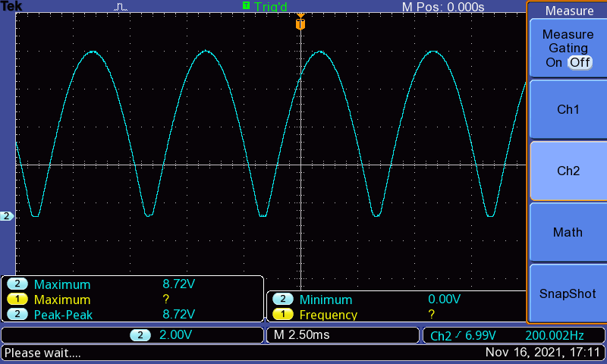

We then replaced C1 and again took a hard copy of the output with the measurements:

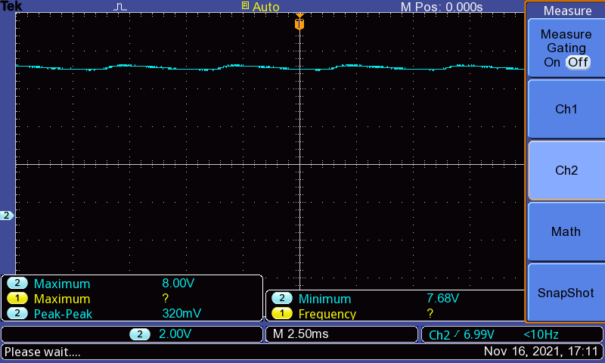

The ripple voltage is provided below:

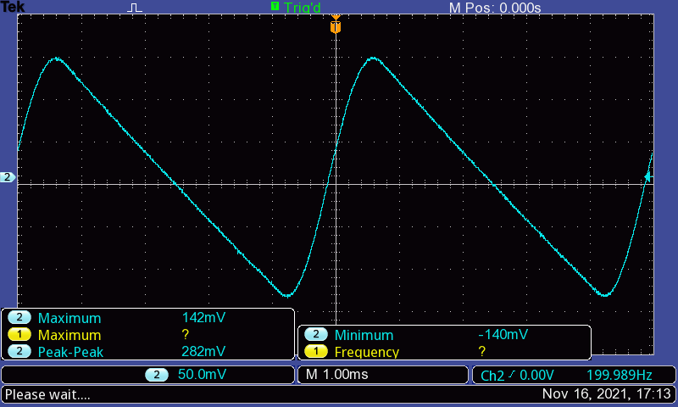

**Problem 3: Zener Diode**

We implemented the following circuit:

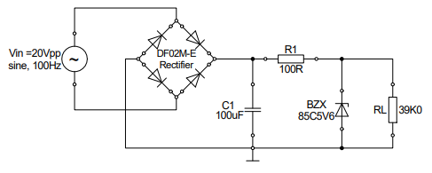

The voltage at C1 is provided below:

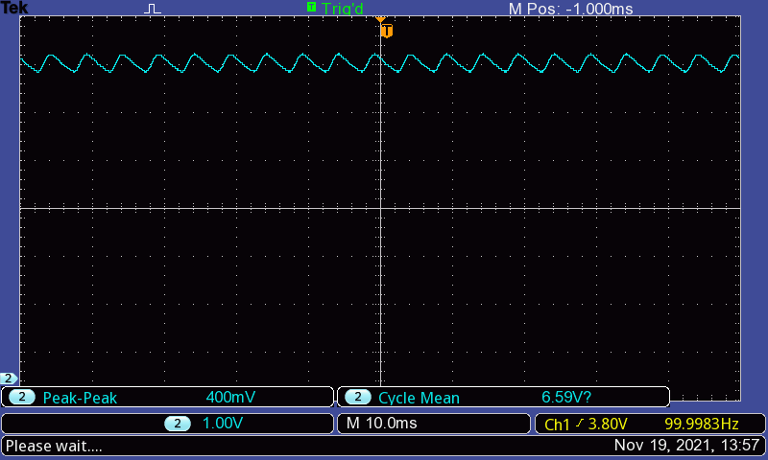

The DC output is provided below:

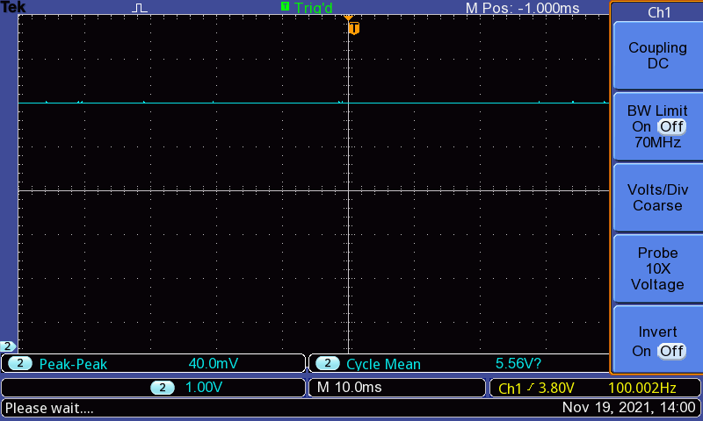

The ripple voltage is provided below:

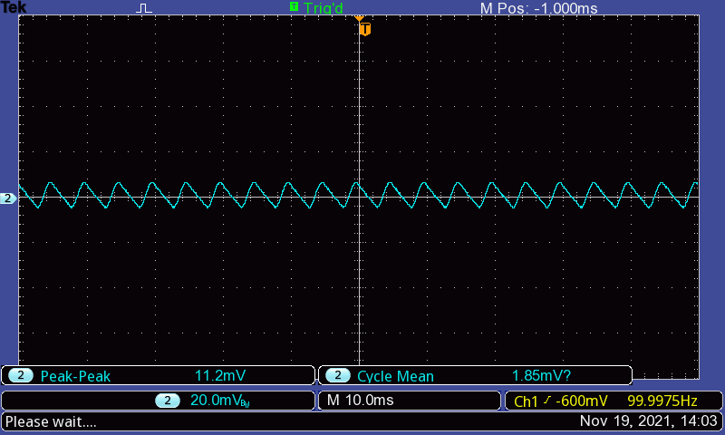

**Problem 4: Voltage Multiplier**

For this task, we implemented the following circuit:

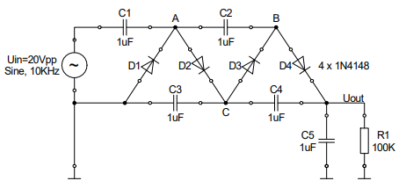

We then used the oscilloscope to measure the voltage at ‘A’ and ‘C’. We obtained the following:

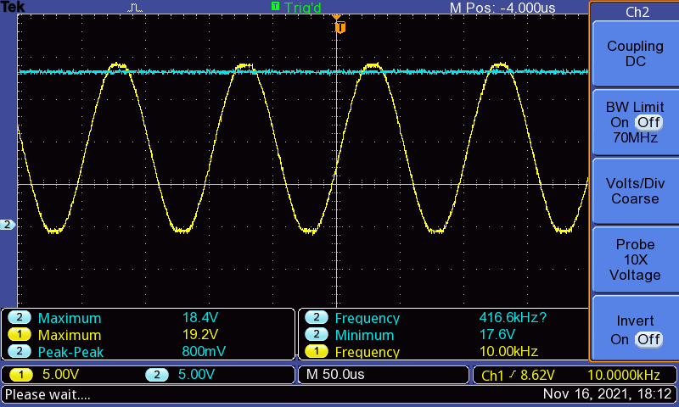

Then, we used the oscilloscope to measure the voltage at B and Vout. The results are as follows:

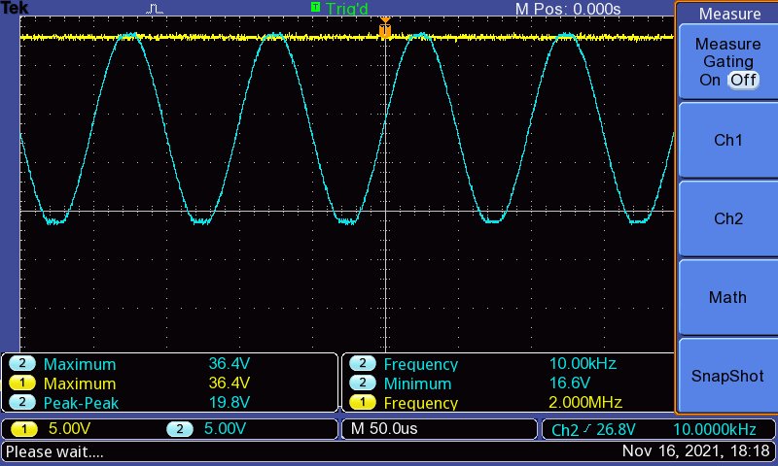

The ripple voltage at Uout looked as follows:

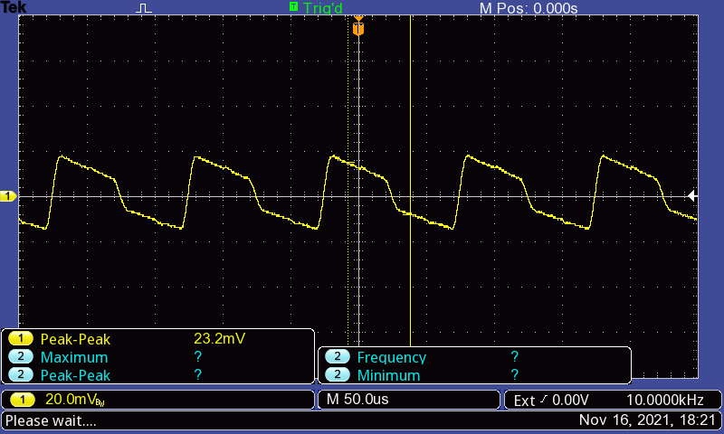

We then used the multimeter to measure the voltage at ‘C’ and Uout. We found the following results:

**Evaluation**

**Problem 1: Diode Switching Characteristic**

Question 1

It can be observed from the experimental data that 1N4148 has a much smaller storage time than that of the 1N4001.

When switching between states, the diode needs to discharge any stored charges, before diode characteristics such as blocking or allowing current flow come into action. This is because the charge carriers inside the diode require some amount of time to react to external changes and shift between the PN Junction. Consequently, we see that the diode remains in conduction state for some time even after the external conditions switch to reverse bias; or in non-conduction state for some time after the external conditions have switched to forward bias. One outcome is that the diode requires more time to switch off.

Question 2

Since 1N4001 has a large storage time, we can conclude that it is unsuitable for processes such as AM Modulation of high frequency signals (several 100kHz). A large storage time could result in loss of information and distortion of the signal: as the diode would require a long time to switch in between states in case of forward or reverse bias, it cannot keep up with the fluctuations in the signal.

1N4148 is more suitable in this regard than 1N4001, since it will be able to keep up with high frequency signal in case of AM Modulation, which means loss of information is less likely.

**Problem 2: Rectifier**

Question 1

Rectifier

AC Signal

Regulator

Filter

DC Signal

The AC Signal is a two-directional fluctuating signal, which is also the source of the circuit, usually provided by the use of a signal generator. The rectifier converts this signal to a one-directional signal for the rest of the circuit, implemented in our experimentation through diode networks. The rectifier output, however, has large fluctuations in it. The filter, implemented by the use of the capacitor in parallel to the load, smoothens the signal by providing power at times when the input is lower than the capacitor voltage. The regulator maintains a constant voltage and current across the output, independent of the fluctuations in the input voltage or current – implemented by the use of the Zener diode. The DC signal is the final output of the circuit, usually measured across the load.

Question 2

|  |  |  |  |
| --- | --- | --- | --- |
| Rectification | (Simulated) | (Calculated) | (Measured) |
| Half-wave | 614.518 | 512.47 | 640 |
| Full-wave | 263.192 | 295.81 | 282 |

Simulated and calculated values are taken from prelab.

The data suggests that the simulated, measured and calculated values correlate with each other to a certain extent, which means the values confirm each other. The slight difference in the measured value is noticeable, and it can be attributed to the resolution of the oscilloscope, precision error when taking measurements using cursor, and error of the signal generator. Other components, such as the diodes and capacitors, are not ideal, so they could also contribute to the error through some kind of internal resistance or storage time required when shifting between states. We also have to take into account that the formula in the manual only approximates the ripple voltage, and does not provide the exact value.

**Problem 3: Zener Diode**

In lab, we took measurements on the following circuit:



Based on lab data, we have the following results:

Cycle Mean:

Using KCL, we know:

**Problem 4: Voltage Multiplier**

Question 1

The circuit in this experiment is composed through a combination of the clamper circuit and some rectifier circuits.

Question 2

The positive clamper circuit adds a positive DC voltage level to a signal. The clamper circuits can be used to restore dc levels in circuits that have passed through different filters.

The diode rectifies an ac voltage, so that it can be smoothed and converted into a dc voltage. The capacitor acts as a smoothing filter so that the output is nearly a dc voltage. When we put these together using different networks, we are able to convert a two-directional AC voltage to a single directional DC voltage, with a small ripple that is the residue of the AC.

In the provided network, clampers are used to add a DC voltage level to the signal, without effecting the shape of the signal itself. This signal is then converted to a smoothened dc voltage (with a small ripple) through rectification.

Question 3

There are four clampers in this network, so the DC output should be 4 times the input amplitude.

Ideal values:

Measured values:

The diodes used in this network require a minimum operating voltage. This minimum voltage across the diodes is important for the operation of the diodes, and therefore the whole network. Therefore, at each of the diodes there is a voltage drop. Hence, the resulting voltage across the load is lower than the supply voltage due to potential drops that the diodes. As a result, the measured output is lower than the ideal output.

Question 4

The voltage at each element is twice the amplitude, therefore, at least two times the peak voltage is required. The maximum voltage at each element is Vpp.

Question 5

If the frequency is reduced to 100Hz, it will cause a reduction in the . At higher frequency, the capacitors are charged more frequently, so that also means higher frequency circuits will also have a lower ripple than that of a circuit functioning at 100Hz.

To verify our claim, we build the following circuit in LTSpice:

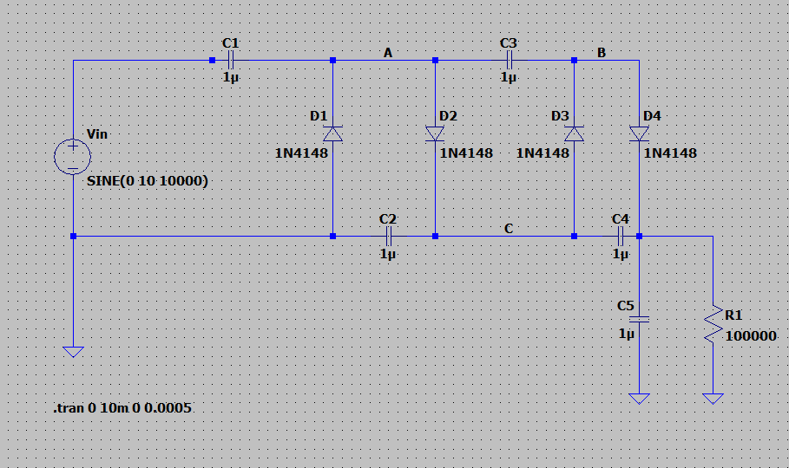

At 10kHz, we obtain the following results:

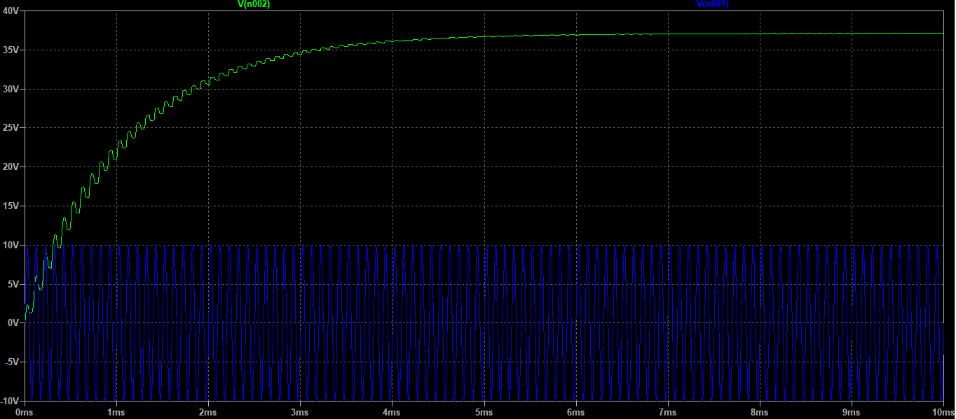

At 100 Hz, we see the following plot:

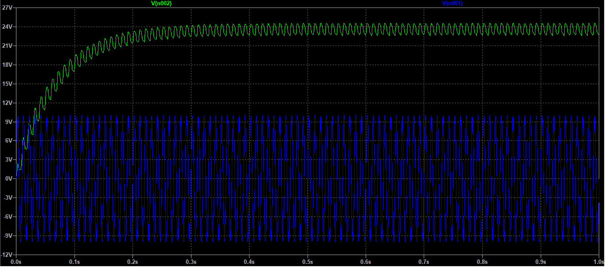

As we can see, the output voltage is smaller at 100 Hz that that at 10kHz. Also, the ripple is smoother for the 10 kHz circuit and the output stabilizes much faster – compared to the 100Hz circuit results.

**Conclusion**

In this lab, we studied the characteristics of diodes and their application. During prelab, we simulated different diode circuits using LTSpice and studied their characteristics. We first studied a simple diode circuit and understood how a diode functions in forward bias. We simulated the circuit and generated plots of the diode current versus voltage using linear and logarithmic scales. Using the simulated plots, we were able to calculate the diode’s characteristic constants such as the saturation current and the diode factor. Then, we studied the halfwave rectifier and the full wave rectifier. We simulated the circuit and observed changes in U_L, Vin and I_D in presence and in absence of the capacitor. We then determined the ripple voltage at the output, and compared it with the theoretical result we obtained using the theoretical formula. We noticed that the presence of the capacitor is important in the rectifier circuit to achieve the smoothing effect. We also noticed that the half wave rectifier blocks negative cycles while the full-wave rectifier inverts them. As a result, the ripple output of the full-wave rectifier is smoother. Then, we simulated a circuit with a Zener diode and performed its transient analysis by plotting the input voltage and output at the load resistor. We saw that this circuit acts as a regulator by keeping the voltage across the load constant, independent of the fluctuations of the input voltage and current.

In the lab, we were able to implement the circuits we simulated for prelab, and compare the results we obtained with experimental data. In the first part of the lab, we observed that diodes have a delay time and a storage time between forward/reverse transitions, resulting from time taken by carriers within the diode to resettle after a transition. In the second part, we studied a half-wave and a full-wave rectifier. We implemented the circuits using lab components and generated the outputs on the oscilloscope. We replicated the same actions in lab as our simulations, and observed that the results confirmed each other. Then, we implemented a full-wave rectifier with a regulator, and observed that this combination actually provides a much better DC output from what we had previously obtained, because the regulator prevents large fluctuations across the load. Lastly, we studied a voltage multiplier, which is constructed by using a combination of the clamp circuit and the rectifier circuit. We analyzed the signal generated by the voltage multiplier network at different points using the oscilloscope and the multimeter, and then used the oscilloscope to obtain the ripple voltage at output.

For first part of evaluation, we compared how storage time of some diodes might make it practical or impractical in different situations. We studied the building blocks of DC power supply, and compared our measured data from the full-wave and half-wave rectifier experiments with our simulated and calculated data. We were able to conclude that, in this case, the data confirm each other, despite some deviation in their values. For the third experiment, we evaluated the current passing through the Z-diode based on our lab measurements. In the fourth part of our evaluation, we studied the voltage multiplier network some more. We concluded that combination of the clamper circuit and the rectifier circuit could result in the voltage multiplier network that we implemented in lab. We also noticed how presence of diodes could result in a different output voltage in lab when compared to the theoretical output. We them simulated the circuit network with different input frequencies (100 Hz and 10kHz), and noticed some considerable differences in output. The voltage multiplier operating at 10kHz resulted in a higher output volage and smoother ripples when compared to that operating at 100 Hz.

Overall, we used simulation, theoretical constructs and experimental data to study different characteristics, combinations and applications of diodes and diode-based networks. This gave us a deep understanding how to use a basic semiconductor device to accomplish some unique tasks in combination with other electrical components. We also obtained an understanding of how this device might deviate from its theoretical characteristics based on diode-type, circuit type etc. As a result, we were prepared to recognize error sources and realize what to expect in an experimental situation as opposed to a theoretical situation.

**References**

* Signals and Systems Lab Manual (Uwe Pagel)
* http://www.faculty.jacobs-university.de/upagel/